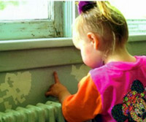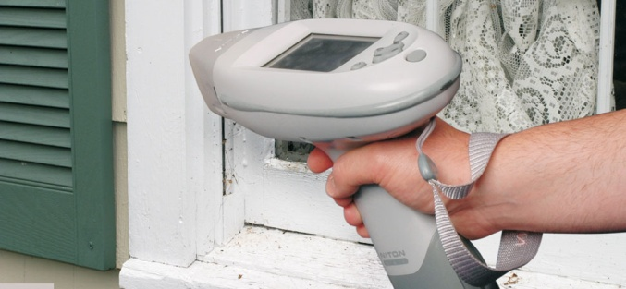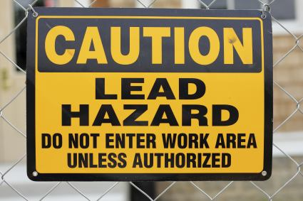[](http://www.bing.com/images/search?q=Cute+Black+Baby+Girls&Form=IQFRDR)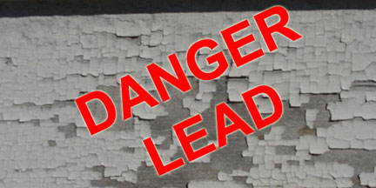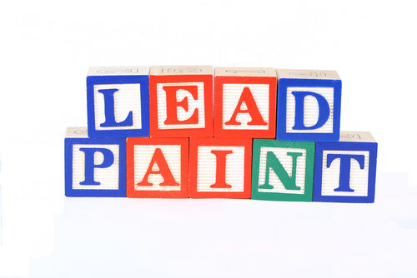

**October 26-28, 2022 Virtual Training**

A Professional development workshop sponsored by The NC Environmental Health State of Practice Committee, Children’s Environmental Health Program and DHHS

**Lead Investigation**

**&**

**Remediation Workshop**