Group Activity

|  |
| --- |
| **State of Practice Lead Investigation & Remediation Workshop** |

[](http://www.bing.com/images/search?q=Cute+Black+Baby+Girls&Form=IQFRDR)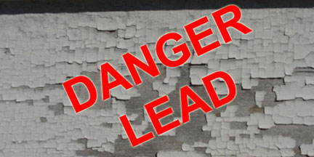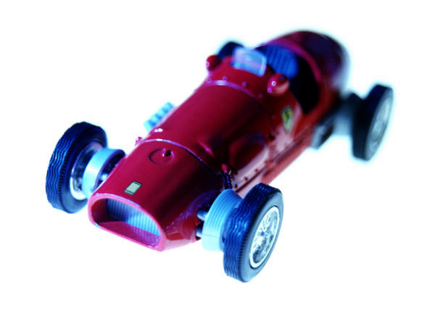

|  |  |
| --- | --- |
| SOP | Lead Remediation workshop |

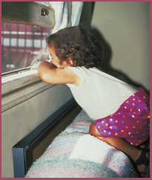

(1) List all possible lead hazards/concerns associated with each photo. (2) What test would you recommend to determine if hazards are present? (3) List possible remediation options including interim controls.

[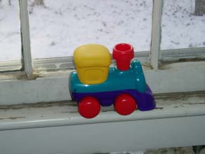](http://www.jrvhomeinspections.com/files/lead_window_train.jpg)SEARCH HISTORY

* [photos of lead based paint housing](http://www.bing.com/images/search?q=photos+of+lead+based+paint+housing&view=detail&id=F4E77BA429050EC1CEB3F82EE9F4338593A27098&first=1&FORM=O1FD)
* [religious family silhouette images](http://www.bing.com/images/search?q=religious+family+silhouette+images&view=detail&id=77B43D2FCE720839090CE1A8C8E8F5DF7527C34B&qpvt=religious+family+silhouette+images&FORM=O1FD1)
* [family siloutette clip art](http://www.bing.com/images/search?q=family+siloutette+clip+art&qpvt=family+siloutette+clip+art&FORM=O1FD2)
* [See all](http://www.bing.com/profile/history?q=photos+of+lead+based+paint+housing&FORM=O2FD)
* [Clear all](http://www.bing.com/profile/history/delete?rp=%2fimages%2fsearch%3fq%3dphotos%2bof%2blead%2bbased%2bpaint%2bhousing%26view%3ddetail%26id%3d14911DC4D9AFF738DA3B192657104E36858E71D4%26first%3d36&FORM=O2FD1) · [Turn off](http://www.bing.com/historyHandler?oma=toggle_off&sig=530E262D86814B9887755D8E003DC222&rp=%2fimages%2fsearch%3fq%3dphotos%2bof%2blead%2bbased%2bpaint%2bhousing%26view%3ddetail%26id%3d14911DC4D9AFF738DA3B192657104E36858E71D4%26first%3d36&FORM=O2FD2)

%first%-%last% of 25,600 results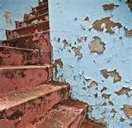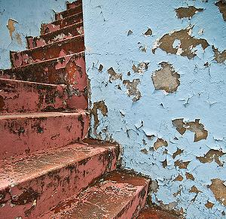

[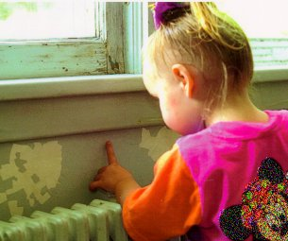](http://www.easy-house-painting-tips.com/images/Lead_Paint_Child.jpg)

(1) List all possible lead hazards/concerns associated with each photo. (2) What test would you recommend to determine if hazards are present? (3) List possible remediation options including interim controls.

http://www.bing.com/mm/s/loading_lg.gif[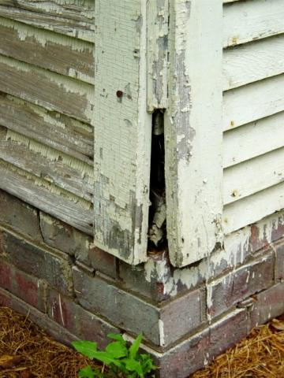](http://renovatedsm.com/files/images/leadpaintscaling.preview.jpg)

[Type sidebar content. A sidebar is a standalone supplement to the main document. It is often aligned on the left or right of the page, or located at the top or bottom. Use the Text Box Tools tab to change the formatting of the sidebar text box.

Type sidebar content. A sidebar is a standalone supplement to the main document. It is often aligned on the left or right of the page, or located at the top or bottom. Use the Text Box Tools tab to change the formatting of the sidebar text box.]

[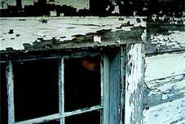](http://www.bing.com/images/search?q=photos+of+lead+based+paint+housing&view=detail&id=A9E4FFF897AD60D9FD59ECDCF8260E6CE46F22CC&first=1)Displaying this page may force you to leave Bing Images. Opening the page in a new window will prevent this.  
Open in a new window | Open here

[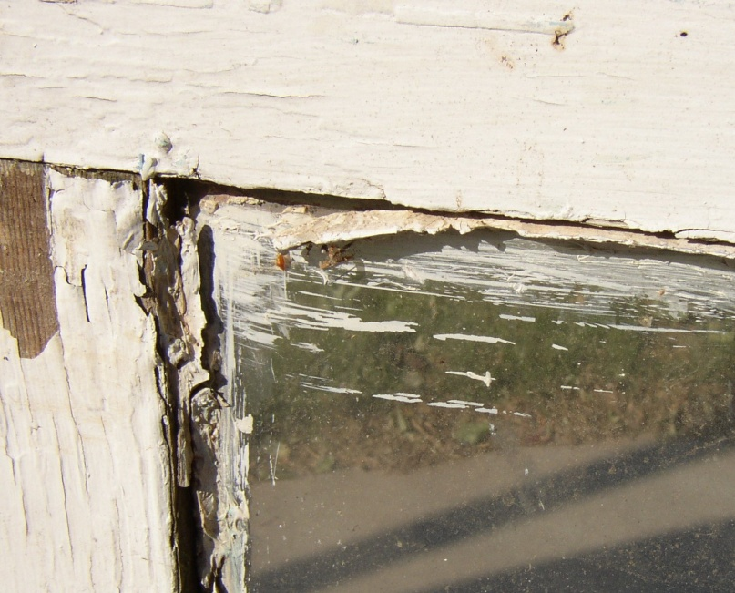](http://sage-earth-sciences.com/asbestos/window.jpg)

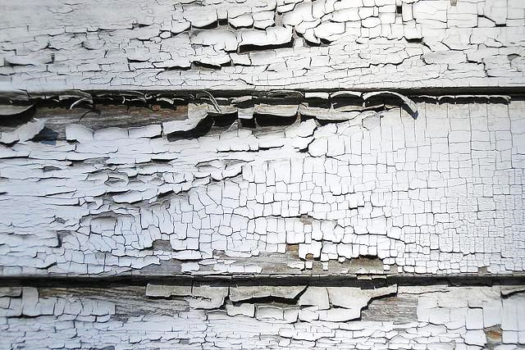

(1) List all possible lead hazards/concerns associated with each photo. (2) What test would you recommend to determine if hazards are present? (3) List possible remediation options including interim controls.

Question: Testing of paint indicated that there was no lead paint hazard. However, this area was still deemed to be a source of lead exposure for children. How?

[](http://www.suburbanwindowsnsiding.com/Portals/55439/images/leadpaint6-resized-600.jpg)

Does NC have lead standards related to miniblinds? If so, what is that standard and where is it found?

[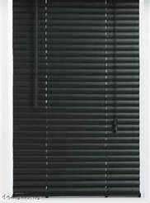](http://www.windowblindscurtain.com/wp-content/uploads/2011/08/Black-Mini-Blinds-image.jpg)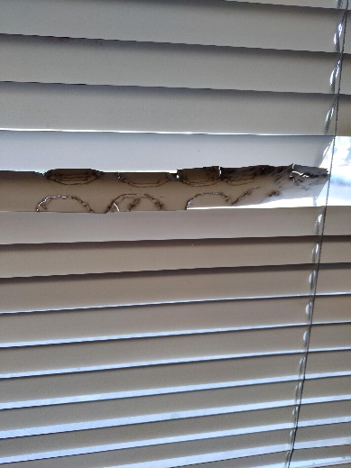

[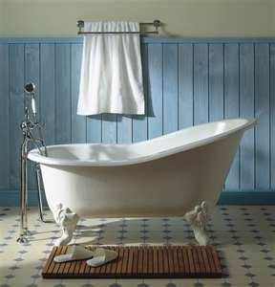](http://www.bathroomremodelings.org/wp-content/uploads/2011/03/Cast-Iron-Bathtub.jpg) [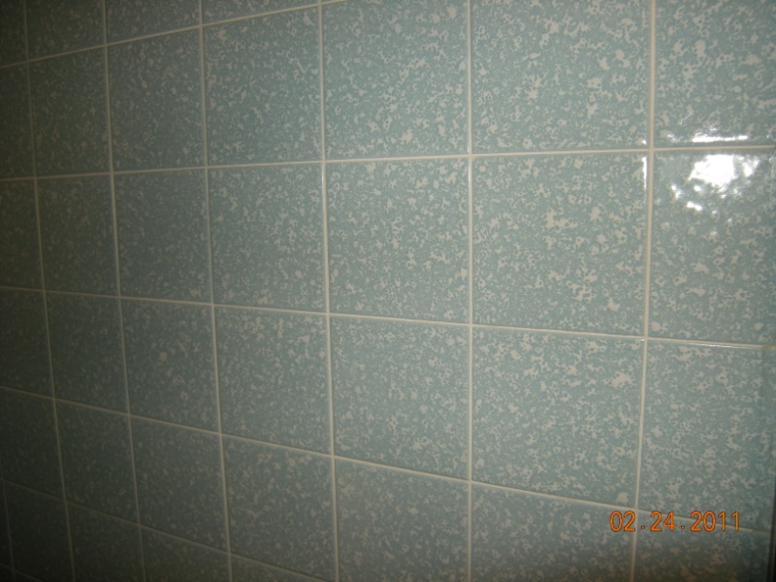](http://www.promotinghealthyhomes.com/wp-content/uploads/2011/03/DSCN1768.jpg)

**Bathroom Potential Issues**

Does NC have lead standards related to tubs? If so, what is that standard and where is it found?

(1) List all possible lead hazards/concerns associated with these bathroom items. (2) What test would you recommend to determine if hazards are present? (3) List possible remediation options including interim controls.

[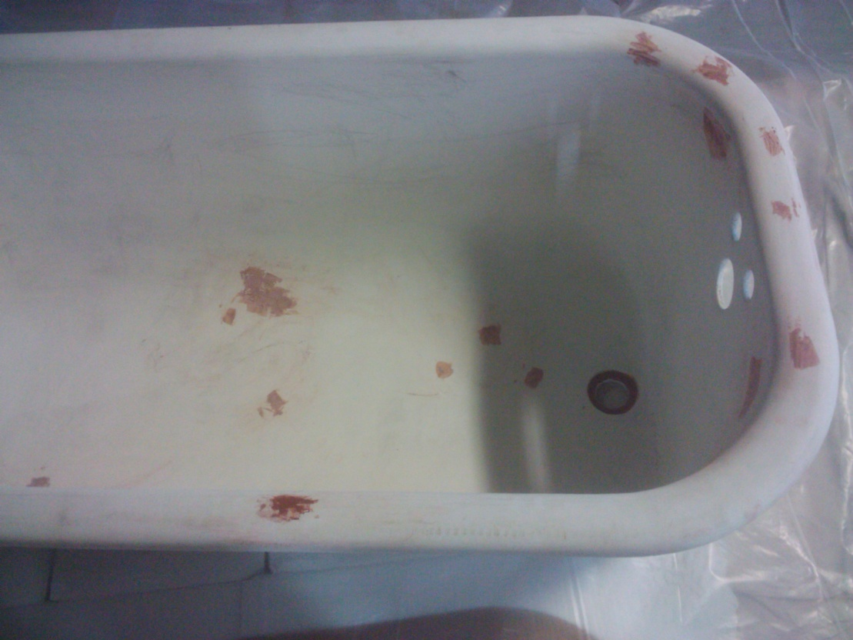](http://www.intouchpaintinginc.net/clawfoot-bef-4-20-12-n.kinstown.JPG)

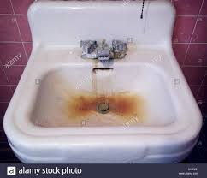

[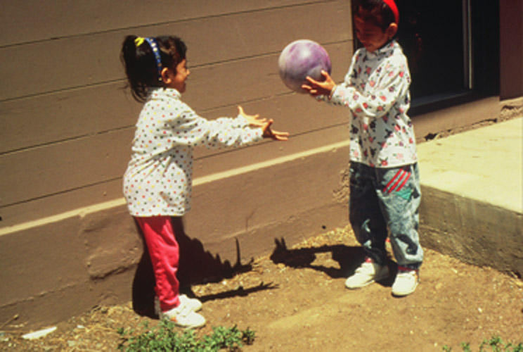](http://www.co.marin.ca.us/depts/HH/main/hs/CHPS/CLPPP/Images/soil4.jpg)

(1) List all possible lead hazards/concerns associated with each photo. (2) What test would you recommend to determine if hazards are present? (3) List possible remediation options including interim controls.

[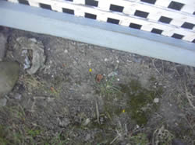](http://houseinvestigations.com/images/lead_clearance/exposed_soil.jpg)

[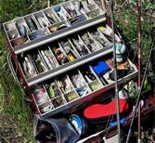](http://www.bing.com/images/search?q=picture+of+a+fishing+tackle+box&view=detail&id=4FD074DAF0DA5073675A4690CE547BA22566A516)

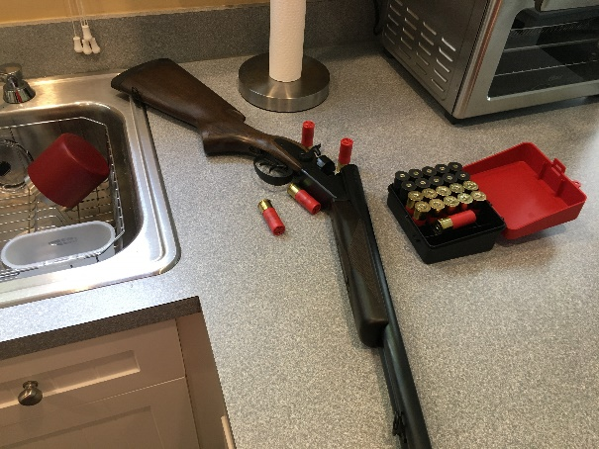

**Exterior Structures**

(1) Compare all the exterior structures. Assuming all structures are positive for lead, how would your suggestions of remediation options differ based on condition?

[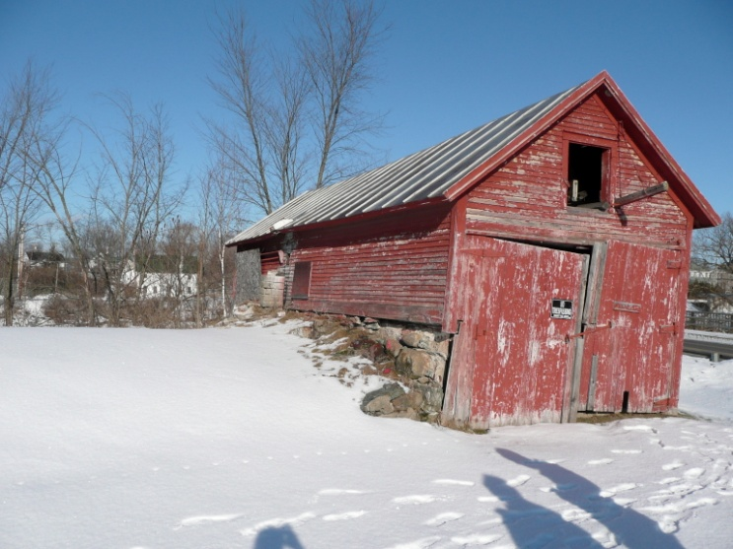](http://claypointassociates.com/wp-content/uploads/2011/01/P1000740.jpg)

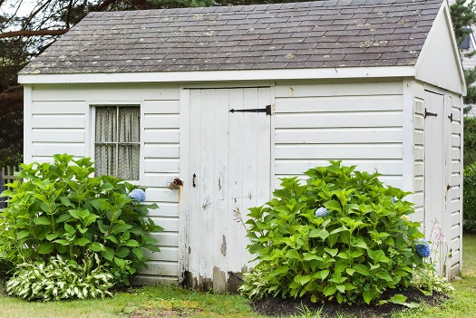

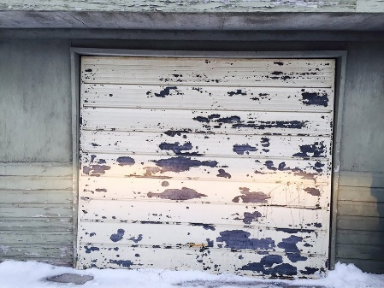

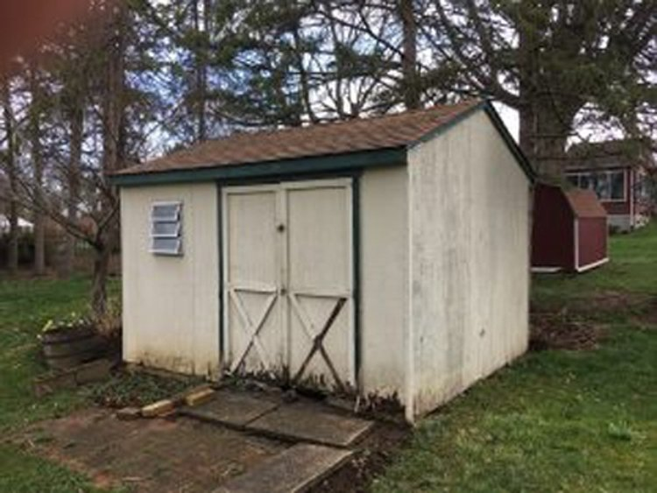

[](http://blogs.wickedlocal.com/newton/files/2007/11/pic_toys.jpg)

(1) What test would you recommend to determine if lead hazards are present? (2) Is there an acceptable level of lead in toys? If so, what? (3) Who regulates this?

[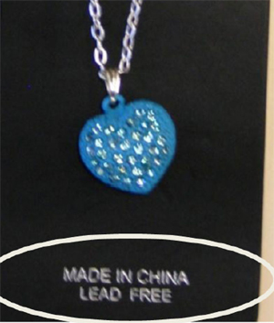](http://blog.timesunion.com/hottopics/files/2012/03/blueheart.jpg)

[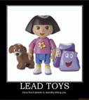](http://www.bing.com/images/search?q=pictures+of+lead+toys&view=detail&id=017D30C67751BE0EF91C705D3526E8DC363E6E2B&qpvt=pictures+of+lead+toys)

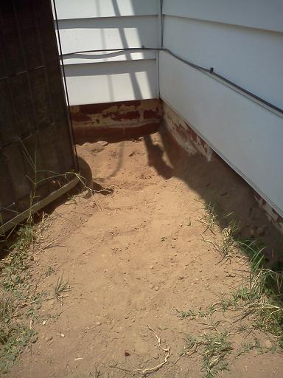

(1) List all possible lead hazards/concerns associated with each photo. (2) What test would you recommend to determine if hazards are present? (3) List possible remediation options including interim controls.

[Type sidebar content. A sidebar is a standalone supplement to the main document. It is often aligned on the left or right of the page, or located at the top or bottom. Use the Text Box Tools tab to change the formatting of the sidebar text box.

Type sidebar content. A sidebar is a standalone supplement to the main document. It is often aligned on the left or right of the page, or located at the top or bottom. Use the Text Box Tools tab to change the formatting of the sidebar text box.]

